The goal for this project was to build an item-tracking program for Corner Grocer to effectively rearrange their produce section according to purchase frequency for customers. Given all the parameters of what was required, I developed a C++ program that would assist Corner Grocer track the purchases of produce throughout the day.

I was able to design the Grocery Tracker class that would handle the main functionality of the data received. With the assistance of sections 6.2 and 6.3 from zyBooks , I was able to to define and use a class in C++ (zyBooks, 2025). I used a map to store the item names and the purchase frequency of the produce. Within the Grocery Tracker class, I was able to load data from a text file, search the frequency of a specific item, print all produce with its corresponding purchase frequency, display a histogram made of asterisks, and create a backup file (frequency.dat)-using sections 7.1, *File Input*, and 7.3, *File Output*, in zyBooks (zyBooks,2025).

The program begins by reading and processing the text file given (CS210_Project_Three_Input_File.txt) and developing the backup file. From there, a display menu shows four options – search for an item, print all produce frequencies, show produce histogram, or exit. Input validation was used to ensure the user entered a valid option and each option referred back to the Grocery Tracer class to keep everything organized.

In developing the program, I followed all best practices making sure I my variable names were clear, inserting inline comments, and creating readable code. Furthermore, I tested every menu option to ensure proper function.

Menu:

Item Search for Peas:

Frequency List:

Frequency Histogram:

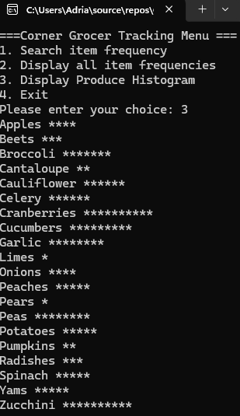

**References**

zyBooks. (2025). *CS 210: Programming Languages*. Section 6.2: Using a class; Section 6.3: Defining a class. Retrieved from https://learn.snhu.edu